**Project Report**

**On**

**Creating a Asian paints**

**Chatbot**

Developed By:- Guided By:-

Harsh Wani(18162121039) Prof. Parth Parekh(Internal)

Harsh Parmar(19162122001) Prof.Krishna Pal(IBM)

Yash Kayasth(19162122002)

**Submitted to**

**Department of Computer Science & Engineering**

**Institute of Computer Technology**



**Abstract :**

Chatbots, or conversational interfaces as they are also known, present a new way for individuals to interact with computer systems. Traditionally, to get a question answered by a software program involved using a search engine, or filling out a form. A chatbot allows a user to simply ask questions in the same manner that they would address a human. The most well known chatbots currently are voice chatbots: Alexa and Siri. However, chatbots are currently being adopted at a high rate on computer chat platforms.

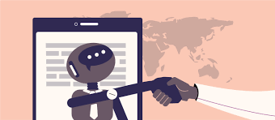

**Objective:**

Chatbots are being made to ease the pain that the industries are facing today. The purpose of chat bots is to support and scale business teams in their relations with customers. It could live in any major chat applications like Facebook Messenger, Slack, Telegram, Text Messages, etc.

Applications of chatbot in Business:

### ****1. Accessible anytime****

### ****2. Handling Capacity****

### ****3. Flexible attribute****

### ****4. Customer Satisfaction****

### ****5. Personal Assistant****

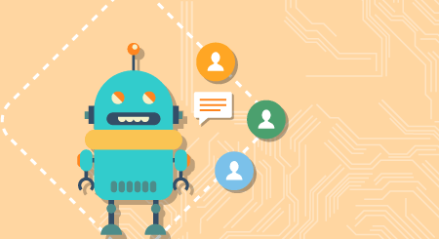

**Steps for making a chatbot:**

1. Determine the goals and role of the chatbot.
2. Create a Conversational Architecture (intents, dialogs etc.).
3. Design the dialog flows.
4. Design the integrations.
5. Testing of the chatbot on different platforms.

**A Retrival based Chatbot:**

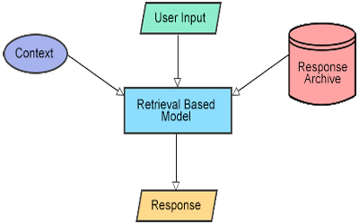

Retrieval based bots work on the principle of directed flows or graphs. The bot is trained to rank the best response from a finite set of predefined responses. The responses here are entered manually, or based on a knowledge base of pre-existing information.

**Related Background (code):**

from chatterbot import ChatBot

from chatterbot.trainers import ListTrainer

from tkinter import *

bot = ChatBot("AsianPaintsChatbot")

convo=[

'Hello',

'Hi !!',

'What is your name ',

'I Am Asian Pains Chatbot ,Created by Asia Paints',

'How Are you ?',

'I Am doing Great these Days',

'thankyou',

'In which city you live ?',

'I Live in Ahmedabad',

'In Which Language you talk ? ',

'I Mostly Talk in English'

]

trainer=ListTrainer(bot)

#train the bot

trainer.train(convo)

main=Tk()

main.geometry("500x650")

main.title("Asian Paints Chatbot")

img=PhotoImage(file="logo2.png")

photol=Label(main,image=img)

photol.pack(pady=5)

**Related Background (Cont):**

def ask_from_bot():

query=textf.get()

ans_from_bot=bot.get_response(query)

msgs.insert(END,"You: "+query)

msgs.insert(END,"Bot: "+str(ans_from_bot))

textf.delete(0,END)

msgs.yview(END)

frame=Frame(main)

sc=Scrollbar(frame)

msgs=Listbox(frame,width=80,height=20,yscrollcommand=sc.set)

sc.pack(side=RIGHT,fill=Y)

msgs.pack(side=LEFT,fill=BOTH,pady=10)

frame.pack()

#create text fild

textf=Entry(main,font=("Verdana",20))

textf.pack(fill=X,pady=10)

btn=Button(main,text="Ask from Bot",font=("Verdana",20),command=ask_from_bot)

btn.pack()

def enter_function(event):

btn.invoke()

#going to bind windw with enter press

main.bind('<Return>',enter_function)

main.mainloop()

**Expected Outcome:**

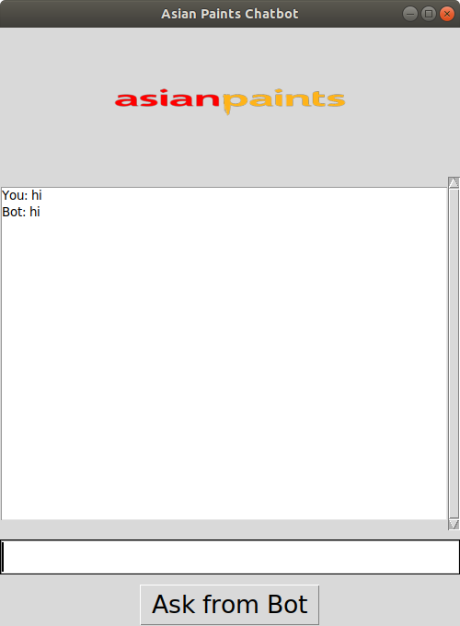

**Expected Outcome (Cont):**

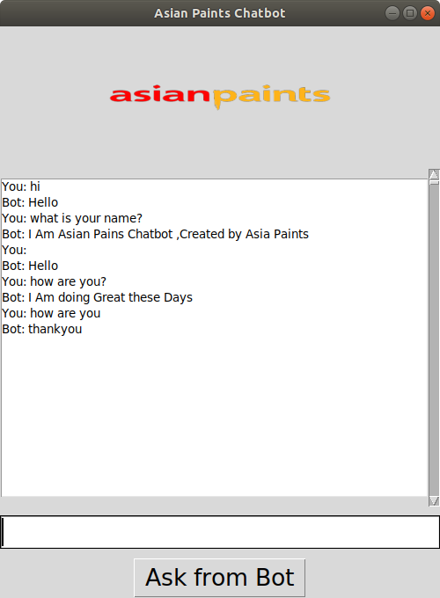

**SOFTWARE SPECIFICATIONS**

* OPERATING SYSTEM : Windows 10
* ENVIRONMENT : Ubuntu (18.04.3)
* PROGRAMMING : Python

LANGUAGE

* DOCUMENTATION : MICROSOFT WORD

**HARDWARE SPECIFICATIONS**

|  |  |
| --- | --- |
| ➢ PROCESSOR | : INTEL CORE i3  7th generation |
| ➢ RAM | : 8GB MB |
| ➢ MONITOR | : 14” COLOR |
| ➢ HARD DISK | : ----- |
| ➢ FLOPPY DRIVE | : ----- |

Coclusion:

From my perspective, chatbots or smart assistants with artificial intelligence are dramatically changing businesses. There is a wide range of chatbot building platforms that are available for various enterprises, such as e-commerce, retail, banking, leisure, travel, healthcare, and so on.

Chatbots can reach out to a large audience on messaging apps and be more effective than humans. They may develop into a capable information-gathering tool in the near future.

